Switch Statements

What are they.....

A switch statement is the other main method we will be using to condition check. A switch statement allows a variable to be tested for equality against a list of values. Each value is called a case, and the variable being switched on is checked for each switch case.

Some of the rules for using a switch statement.....

* The expression used in a switch statement must have an integral or enumerated type, or be of a class type in which the class has a single conversion function to an integral or enumerated type.
* You can have any number of case statements within a switch. Each case is followed by the value to be compared to and a colon.
* The constant-expression for a case must be the same data type as the variable in the switch, and it must be a constant or a literal.
* When the variable being switched on is equal to a case, the statements following that case will execute until a break statement is reached.
* When a break statement is reached, the switch terminates, and the flow of control jumps to the next line following the switch statement.
* Not every case needs to contain a break. If no break appears, the flow of control will fall through to subsequent cases until a break is reached.
* A switch statement can have an optional default case, which must appear at the end of the switch. The default case can be used for performing a task when none of the cases is true. No break is needed in the default case.

Lets have a look at a couple examples.....

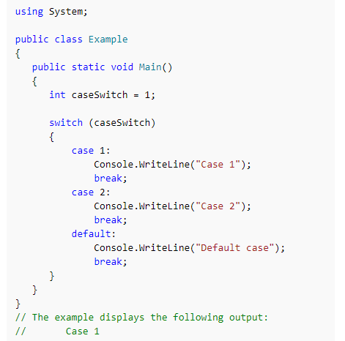

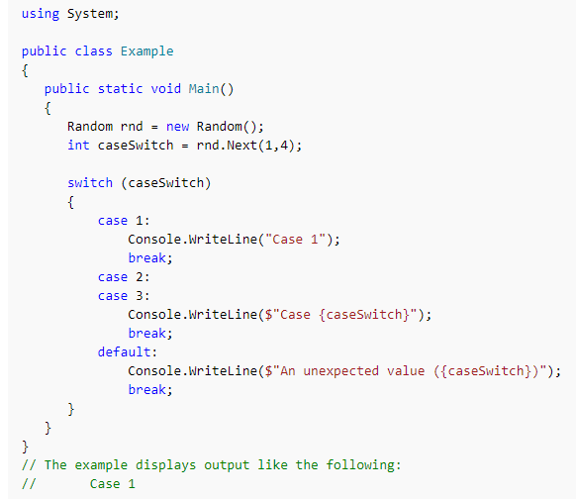

Exercises.....

**1. Guess My Favorite Pet**

Write a program that asks the user to enter the name of a type of pet (ie. dogs, rabbits, chickens or parrots) in order to guess the favorite pet type. A message indicating if the guess was correct or incorrect is output to the browser console. The favorite pet type is preset in the program code, ie. assigned to a variable. A message is displayed to the user if they enter an unrecognised pet.

**2. What is the Price of the Fruit**

Write a program that asks the user to enter the name of a fruit variety in order to return the price per kilogram. A message indicating the name of the fruit and its price is output to the browser console. If an unknown fruit type is entered, a message will inform the user. The prices of the fruits are preset in the program code as constants. The following table shows the known fruit types and their cost per kilogram:

**Fruit Variety     Price ($/kg)**

Apples                  1.25

Bananas               3.15

Kiwifruit                4.65

Oranges               2.75

**3. Calculator**

Write a program that asks the user to enter two numbers and an operator (**+**, **-**,**\***, or**/**). The program will perform the calculation on the two numbers as defined by the input operator. The result of the calculation is output to the browser console. If an unknown operator is entered, a message will inform the user. For this exercise, do not concern yourself with checking the two input numbers as being valid numeric values. However, test what happens when you enter a non-numeric input for one of the numbers.